Box or Package Vending / Caterpillar / Belt Drive Motor
Multipurpose DC Gear Motor for Vending Machines
Model No. | Specification
Part Number | 301604-003 | Max Eff. Speed | 22 RPM ± 10%
Voltage Range | 9.00 – 15.00 VDC | Max Eff. Current | 0.570 Amp
Operating Voltage | 12.00 VDC | Max Eff. Torque | 11.25 Kg-cm
Reduction | 1:322 | Max Eff. Power | 2.60 W
Direction of Rotation |  | Max Power | 4.80 W
No Load Speed | 27 RPM ± 10% | Max Power Speed | 14 RPM ± 10%
No Load Current | 0.150 Amp | Max Power Current | 1.380 Amp
No Load Power | 1.80 W | Max Power Torque | 33.76 Kg-cm
 |  | 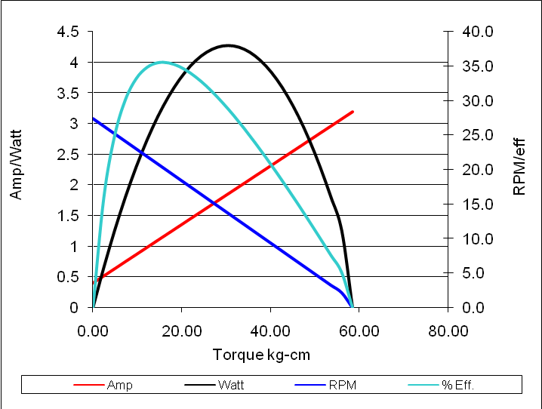
CONNECTION SYSTEM
Pin 1 – Motor 12 VDC +
Pin 2 – Switch NC Empty
Pin 3 – Switch NO Empty
Pin 4 – GND
Pin 5 – GND
Pin 6 – Motor ON (GND)

6 | 5 | 4 | 3 | 2 | 1

