
TCD-180M Card Dispenser Technical Information

(Version 1.00)

CONTENTS
1. General description…………………………………………………………………..3
2. Technical description…………………………………………………………………3
3. Control interface………………………………………………………………………4
3.1 Electronic control interface ..4
3.2 RS232 control interface………………………………………………………….....4
3.3 Control description ..5
3.4 Sketch map of circuit ..6
4. Indication of the working condition of the card/ticket dispenser ..6
5. Operation and maintenance ..6
5.1 Installation of the card/ticket dispenser ..6
5.2 Removing and replacing the cartridge ..7
5.3 Card/Ticket loading ..7
5.4 Card/Ticket thickness adjustments ..7
5.5 Safety and maintenance ..8
6. Notice of using safety ..8

1、Main Description of The XCP Model TCD-180M Card/Ticket Dispenser
- Industrial design for debit/credit card dispensing equipment such as; transit, car washes, library debit cards, parking, laundry, toll debit cards, food services and so on.
- Highly adaptability to various thickness and deformed cards.
- Watchdog of hardware and micro-embedded real-time operating system to ensure reliable operation.
- Pre-dispense function accelerate dispensing speed
- Directly connect to the electronic control system
- Automatic buzzer alarm when card/ticket magazine is full
- Automatic reset after the wrong alarm of 100S is triggered
- RS232 and I/O voltage interface is available.
- The card dispensing mode can be selected for multiple card dispensers.
- Adjustable capacity of card/ticket magazine.
- The card/ticket thickness can be adjusted within 0.2mm―2.4mm （Factory default setting is: 0.8mm/.30)
- Main control board slid in design allows for the installation and removal simple, convenient and fast.
- Factory die stamping process in production ensures the products` quality and consistency.

2、Main technology description
- Operating voltage: 12 - 24VDC (MAX current2A, static current 0.1A)
- Working temperature: -30℃ to 70℃
- Working relative humidity: 30-90%
- Work condition: installed in bin
- Card dimension: width :54 ± 0.5 mm x length: 85 ± 0.5 mm
- Thickness: 0.2 – 2.4 mm（adjusted）(Note：Factory default: 0.8mm/.030)
- Material：paper and polyester cards.
- Net weight: 1.5Kg – 3.3 pounds（including card weight）
- Dispensing time: approximately 0.5S at 24VDC
- Card/ticket capacity: 150pcs at 0.8mm - .30 or 300+ at 0.20 – 0.24mm

3、Control interface
I/O and RS232 control interface is available for the TCD-180M card dispenser. I/O control interface is available by the CN3 on the control broad, RS232 control interface is available by the CN7 of Pin 3 (2.54mm)
3.1 Definition of voltage control interface (CN3)
NO. | Signal definition | description
1 | 0V （24V cathode） | operating voltage cathode
2 | +24V（24V anode） | operating voltage anode
3 | 0V（input/output signal） | link with operating voltage anode
4 | PayOut（card issue signal） | Input, low-level（min 200 ms）effective
5 | Reset（reset input ） | input，low-level（min 200ms）effective
6 | 0V (input/output signal) | link with operating voltage cathode
7 | VD (detector input) | input，low level (min 200ms) effective，can be used as enable signal dialing DIP3 on the control broad to the ON position
8 | Call Back（reclaim card） | input，low level effective (min 200ms)
9 | Out OK | Open collect output，Low level effective。When DIP2=OFF, the signal of OUTOK is that card is in the reading place or in taken place；when DIP2=ON，OUTOK will input 300ms impulse after the card is taken away. Otherwise not any signal will be output in the process of dispensing the card.
10 | Lower | Open collector output, low level effective。
11 | Error | Open collector output, low level effective 。
12 | Empty | Open collector output, low level effective。
3.2 RS232 control interface definition (CN7)

NO. | signal definition | description
1 | GND | signal ground
2 | RXD | RS232 series receiving terminal
3 | TXD | RS232 series sending terminal
9600bps baud rate is used by Communication of RS232 interface 9600bps，8 data bit，2stop bit，no parity calibration bit. And the software is used the SDPP of our company. More detail information please see the <<SDPP series data package technology handbook.
3.3 control description
1、Reset
When the card dispenser resets, the first “beep” ”beep” is for self-inspection。If everything is in the normal operating condition, the card dispenser will drive the motor rotation forward for the normal pre-card dispenser operation. The following condition will lead to a card dispenser reset condition.：
① Power “On”；
② The card dispenser received a reset signal or press of a button on the control panel；
③ Error outputs over 100 seconds.
2、Errors during output and processing
There are two situations that will lead to an error output condition：
① When Pre-dispense failure will send a signal for the “beep” ”beep” ”beep” for three short beeps；
② When a checked card is jammed (buzzer beep signal for the “beep” ”beep” short beeps.
③ When an ERROR signal is detected, the card dispenser will reset and clear the signal of error after 100S；In normal circumstances after reset the overtime errors can be cleared, the jammed cards can be automatically recovered, but when the magazine recovery is full, it will continue to send the error signal. Therefore, the user should remind operators to check whether the card/ticket magazine is full or has a different fault.

3、OUTOK output mode setting
There are two ways for OUTOK signal outputs set by the DIP2 of CN9。When DIP2=ON，OUTOK output will accept a card/ticket signal，or when the card/ticket was removed，low level impulse of 300mS will be output；When DIP2=OFF, OUTOK will output a card/ticket ready signal. This will show the card/ticket was sent to the card reader position or removed location.
4、Dispense mode setting
There are two dispenser modes including whole card/ticket dispensing and half card/ticket dispensing which were set by the DIP1 of CN9 on the control broad.
Whole card/ticket dispensing mode: when DIP1＝ON，input payout signal and VD signal is effective under the whole card/ticket dispensing mode. The card will be sent to the reader location and prepare to dispensing card again.
Half card/ticket dispensing mode: when DIP1＝OFF，input payout signal and VD signal is effective under the half card/ticket dispensing mode. The card will be sent to the front-wheel drive and press the terminal end waiting for removed away.
  - sketch map of I/O voltage control interface
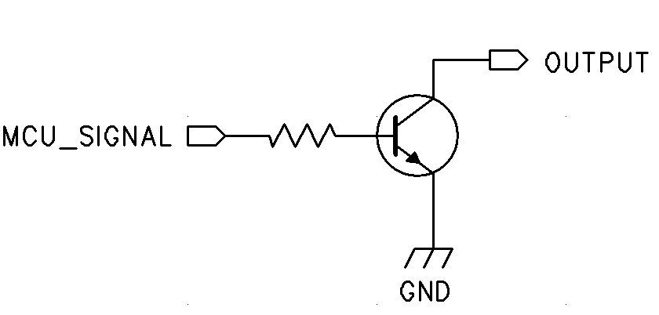
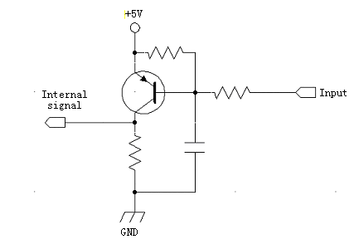
4、Working conditions and indications of the card/ticket dispenser
The red LED of the control board in the card dispenser indicates Voltage status. The several buzzer “beeps” output shows all the various states of the card/ticket dispenser.
NO. | Work condition of card dispenser | Buzzer output | Port output
1 | reset | Consecutive ring “beep, beep” | no
2 | Missing card（can dispense card） | “Beep” Interval ring “beep” | Lower
3 | Jammed card/ticket  （cannot dispense card/ticket） | Interval ring” beep “”beep” | Error
4 | Overtime error  （cannot dispense card） | Interval ring “beep、beep、beep” | Error
5 | Empty | Interval ring “beep、beep、beep、beep、beep” | Empty

5、Operation and maintenance
5.1 Installation
You can install the card/ticket dispenser in the cabinet in accordance with the following method:
Making two installing holes with the diameter of 3mm on the appropriate place to the center line of the mother broad refer to which on the guide rail track bracket. Then the guide rail track bracket should be fixed on the mother broad of the cartridge with appropriate distance ，insert the dispenser into the broad of the guide rail track bracket and the two screws should be fixed on the two sides of the card/ticket dispenser as the last step. The card dispenser installation is finished. Insert the 1x12 signal line plug into the socket at the rear of the card/ticket dispenser. The card/ticket dispenser is now installed and can be checked in the power “on” condition.
5.2 Removing the card/ticket dispenser
The card/ticket dispenser can be removed from the unit when debugging or maintenance by removing the power from the unit and opening the cabinet where it is installed. Carefully remove the 1x12 plug from the circuit board. Loosen the 2 screws and move the card/ticket dispenser along with guide rail track bracket.
5.3 Card/ticket loading
When the buzzer is signaling for the card/ticket magazine being empty or low of inventory，at that time the operator should add additional card/tickets to ensure the normal operation of the card/ticket dispenser system. 。
1、Important! Make sure the added card/ticket thickness matches with the preset adjustment of the card/ticket dispenser mechanism. Please contact the management as soon as possible if the card thickness is not in accordance with the preset setting of the card/dispenser, （un-trained people should not be allowed to calibrate the thickness of the card/tickets.）。
2、The steps of loading card/tickets：
Open the card/ticket cabinet, remove the power, take out the card/ticket weight from the card/ticket dispenser magazine, then place cards or tickets into the magazine. Next, place the card weight on the top of the loaded card/tickets as the last step. Turn back “on” the power and close the door of the cabinet.
5.4 Thicknesses adjusting of card dispenser
The thickness of the card/ticket dispenser can be adjusted to match the thickness of the card or ticket. The adjusted condition of the thickness will affect the complete performance of the card/ticket dispenser. An untrained person should not be permitted to adjust the thickness of the card or ticket.
The main focus of adjusting the thickness of the card is the adjusting of the clearance between the upper separation wheel and the lower bottom separation wheel。The principles of adjusting the card thickness is to make sure the clearance is 1.5 times to the specified card/ticket. The clearance must be the same across from side to side.
The detail for adjusting the clearance ：
First step is loosening the tightener of the strap on the upper separation wheel, the two screws on the top of the adjustment should be backed out 1-2mm, and then loosening the four screws on the two sides of the adjustment’s brackets, selecting the appropriate card and insert into the clearance of the upper separation wheel and the lower separation wheel. Use both hands to adjust the two sides of the adjustment brackets lightly. Make sure the upper separation wheel and the lower separation wheel are equal in height. Tighten the four screws on the two sides of the adjustment brackets and on the top of the adjustment brackets. Load 30 cards or tickets at least and inspection on up. Check that the card/ticket is not being held back or that more than 1 card/ticket is dispensed. When all if checked and functional, drop a spot of glue on all screws and record the thickness of the card on a card or label to be placed on the side of the card/ticket dispenser. Now the card/ticket dispenser can be used again. If the thickness of the card or ticket is changed, it should be readjusted again. Thickness of the plug gauge for reference is listed below in millimeters:
Card thickness | 2.2 | 1.8 | 1.5 | 1.2 | 1.0 | 0.8 | 0.6
Plug gauge thickness | 2.8~3.4 | 2.3~2.8 | 1.8~2.2 | 1.5~1.8 | 1.4~1.6 | 1.1~1.3 | 0.8~1.0

5.5 The normal maintenance and safety
The following situation will appear after the card/ticket dispenser has been used in a period of time or the number of card/tickets has changed the gauge of the distance between the upper and lower rollers：
a) The card/ticket does not dispense until the motor has been running several times.
b) If the card/ticket is not dispensed after running five times and buzzer ring for the “beep” ”beep” ”beep” three short beeps.
The following maintenance work should be implemented immediately:
1、Wipe the surface of the clutch roller (at the base of card magazine) with a cleaning agent-impregnated cloth or pad.
2、Identify the cards or tickets which may have oil on the surface or are deformed seriously。After being cleared by the cloth with cleaning agent-impregnated, the card or tickets can be used again. After being repaired, if the card cannot be used, it should be discarded.
3、Check every part of the card/ticket dispensing machine checking to see if the machine is loose or has any other negative condition or not. If a negative operational condition exists, advise management personnel immediately.
6、Safety using notice
1、Control circuitry must be disconnected from electrical power to the mechanism when the host machine/cabinet is opened for servicing.
2、Inserting or dialing the port connection socket which may damage the control circuit
3、Any liquid spilled on the card/dispenser mechanism should be avoided.
4、Servicing and maintenance staff must be adequately trained and aware of the hazards presented by the rollers and drive belts. The motor drives through a reduction gear creating sufficient torque to trap fingers, hair and clothing of the unwary person.
5、Never hold the dispenser by the magazine alone as it could become detached, allowing the machine to fall which may cause possible injury or damage.
6、Avoid the inclusion of foreign objects such as; liquid, tape, rubber bands and wire as these could cause the machine to jam or short circuit the electronics of the control board.
7、Keep the card/ticket dispenser mechanism clear of contaminants. Oily adhesive substance will seriously affect the performance of the dispenser mechanism.

TCD-180M Card Dispenser Communication Protocol

How the card dispenser communicates with the host computer, the wiring method is as follows:

1.How to connect the card dispenser to DB9 nine-pin female connector
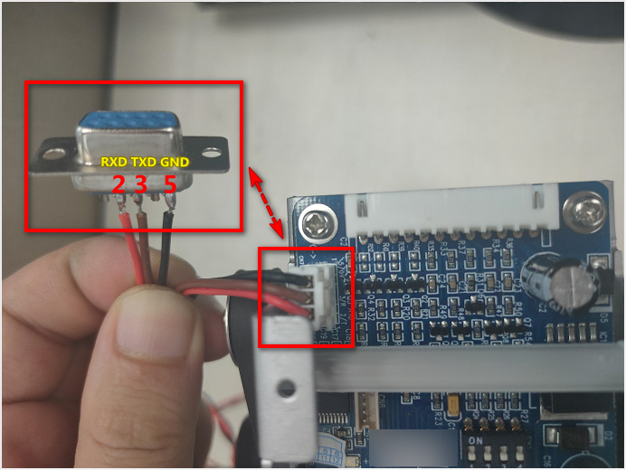

1.2 Wiring method of card dispenser (USB to 232 converter)
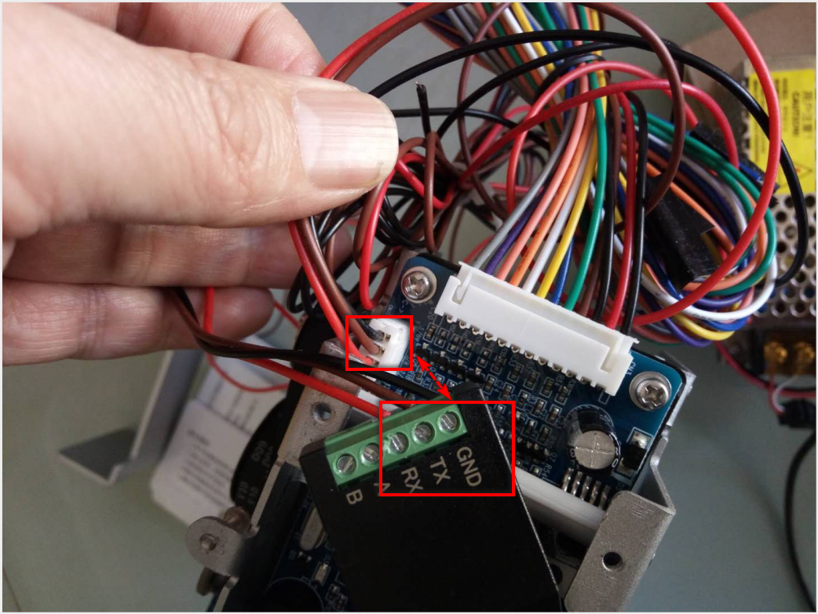

二、RS232 communication protocol

The communication between the card dispenser and the host adopts a standard 8-bit asynchronous data transmission format. After the host sends a frame of command first, the card dispenser will return an ACK signal (0x06) or NAK signal (0x15). If an ACK (0x06) signal is received, the host should send another byte of ENQ (0x05) signal, the card dispenser only then can receive an order to be executed.

Host: Command ENQ
Card Dispenser: ACK/NAK <Execute command or reply command frame>

2.1 Data transfer format
Code: NRZ Baud rate: 9600 Duplex: Half-duplex
Data bit: 8 bit Check bit: None Stop bit: 1 bit

2.2 Host command frame format
Command frame format: <STX> C1 C2 <ETX> <BCC>
<STX>: 02 (HEX), start of command frame
C1 C2 ：Operation command, two-byte ASCII code
<ETX> ： 03（HEX），End of command frame
<BCC> ： <STX>⊕C1⊕ C2⊕<ETX>， Command block XOR check code (⊕ is XOR operator)

2.3 Host operation command
The host sends the following commands to the card dispenser and performs related operations.
Host command | Code(HEX) | description | Reply command
Dispense Card | 44H, 43H | When the card dispenser is in the ready state, after receiving this command, the card is sent from the pre-issuing position or the card reading position to the card taking position | ——
Recycle（CaPture) | 43H, 50H | When the card is in the pre-reading card position or the card taking position, execute this command | ——
Check status  （Request Flag) | 52H, 46H | Return the current status of the card dispenser, and only return one status each time according to the priority (see 3.5.5 Response Command of the dispenser). | ‘S’，’F’
Reset（reSeT） | 53H, 54H | Perform reset operation immediately | ——
Single-step dispense card 1（DH） | 44H, 48H | Single-step dispensing card 1, the card is sent from the pre-issuing position to the card reading position Only valid when DIP1＝ON | ——
Single-step dispense card 2（ES） | 45H, 53H | Single-step dispensing card 2, the card is sent from the card reading position to the card taking position | ——
Fully dispense card （FU） | 46H, 55H | The card is sent directly to the card dispenser from the pre-issuing card position or the card reading position | ——
Query flag  （Poll Bit flag） | 50H, 42H | Query the working status flag bit of the card dispenser, and return the status of 12 flag bits at the same time each time. (For details, please refer to 3.5.6 Issuing Machine Status Flag) | ‘P’,’B’
Clear flag  （Poll Clear flag） | 50H, 43H | Clear the card removed sign and the card recycled sign of the card dispenser. | ‘P’,’C’
Get product version number  (Get Version) | 47H, 56H | Return the 3-byte version number | ‘G’,’V’

2.4 Host operation command code example
The following command code examples are all given in hexadecimal (indicated by the prefix 0x) code
Note: When developing, the prefix 0x does not need to be entered

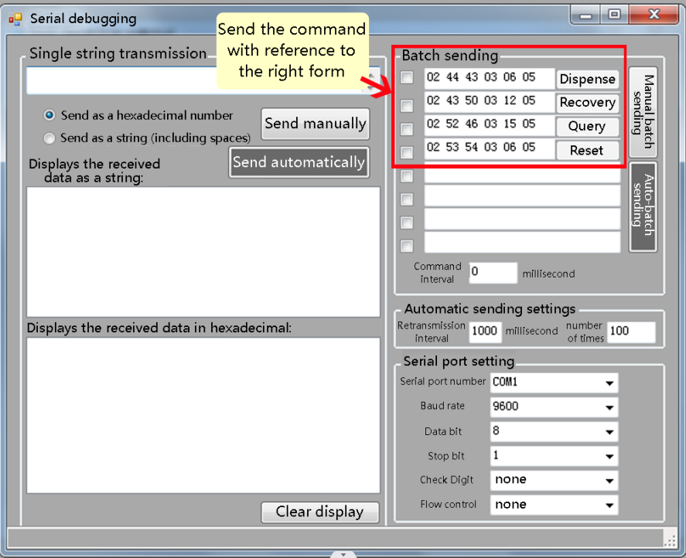
Dispensing command code：0x02,0x44,0x43,0x03,0x06,0x05
Recovery command code：0x02,0x43,0x50,0x03,0x12,0x05
Reset command code：0x02,0x53,0x54,0x03,0x06,0x05
Single-step dispense card 1 code:0x02,0x44,0x48,0x03,0x0D,0x05
Single-step dispense card 2 code:0x02,0x45,0x53,0x03,0x17,0x05
Fully dispense card code：0x02,0x46,0x55,0x03,0x12,0x05
Query work status command code：0x02,0x52,0x46,0x03,0x15,0x05
Query work flag command code：0x02,0x50,0x42,0x03,0x13,0x05
The command code for clearing the flags of the cards that have been taken out and the cards that have been recycled: ：0x02,0x50,0x43,0x03,0x12,0x05
Get product version number command code：0x02,0x47,0x56,0x03,0x10,0x05
When the user host sends a frame of command, the card dispenser will return an ACK signal (0x06) or NAK signal (0x15). If an ACK (0x06) signal is received, the host should send another byte of ENQ (0x05) signal, the card issuer Only then can the received order be executed.

2.5 Card dispenser response command
The response command frame format of the card dispenser is： <STX> R1 R2 D1 D2 D3 <ETX> <BCC>
<STX> : 0 2 (HEX) , Start byte of command frame (hexadecimal code)
R1 ：The first byte of the card dispenser response command (ASCII code)
R2 ：The second byte of the card dispenser response command (ASCII code)
D1 D2 D3 : 3 bytes, the response data information of the card dispenser (ASCII code)
<ETX> : 0 3 (HEX) , Command frame end byte (hexadecimal code)
<BCC> : The one-byte XOR check code is calculated according to the following expression:
<STX>⊕ R1⊕ R2⊕ D1 ⊕ D2 ⊕ D3 ⊕<ETX>
Note: ⊕ is the exclusive OR operator.

2.6“Query status command RF”answer
The response command characters R1 and R2 are "S" and "F". Every three data codes represent a working state, and the response is returned according to the priority in the following table. The state with the lower priority number is returned first.
Priority | Hexadecimal code | Status Description
1 | 0x32,0x30,0x30 | Dispense Card error（Error)
2 | 0x30,0x32,0x30 | Dispense card blocked
3 | 0x31,0x30,0x30 | The recycle bin of card dispenser is full of cards
4 | 0x38,0x30,0x30 | The card dispenser is issuing the card
5 | 0x34,0x30,0x30 | The card dispenser is recycling the card
6 | 0x30,0x30,0x34 | The card has been issued to the card pickup location, waiting for the card to be picked up
7 | 0x30,0x30,0x32 | The card has been issued to the card reading position and is waiting for processing
8 | 0x30,0x30,0x38 | Issuing warehouse card empty
9 | 0x30,0x31,0x30 | Card issuing warehouse is small
10 | 0x30,0x30,0x30 | The card dispenser is ready
11 | 0x30,0x30,0x31 | Pre-issued card is not ready

2.7“Query flag command PB”answer
The response command characters R1 and R2 are "P" and "B". The upper nibble of "D1, D2, D3" is fixed to "3", and each bit in the lower nibble represents a different work flag bit.
D1&(~0x31)：Bit 0 of D1 indicates that the card dispenser's recycling bin is full;
D1&(~0x32):Bit1 of D1 indicates that the card dispenser fails to issue the card normally;
D1&(~0x34)：Bit 2 of D1 indicates that the card dispenser is recycling the card;
D1&(~0x38):Bit3 of D1 indicates that the card dispenser is transmitting the card
D2&(~0x31)：Bit 0 of D2 indicates that the card holder of the card dispenser has a small amount of cards;
D2&(~0x32):Bit1 of D2 indicates that the card sending channel of the card dispenser is blocked;
D2&(~0x34)：D2&(~0x34): bit2 of D2 indicates that the card has been recycled into the recycling bin;
D2&(~0x38)：Bit3 of D2 indicates that the card has been taken away
D3&(~0x31)：Bit 0 of D3 indicates that the card is ready;
D3&(~0x32)：Bit1 of D3 indicates that there is a card in the card reading position;
D3&(~0x34)：Bit 2 of D3 indicates that there is a card in the card pickup position；
D3&(~0x38)：Bit3 of D3 indicates that the card dispenser is empty or not.

2.8“Clear flag command PC”answer
The response command characters R1 and R2 are "P" and "C", "D1, D2, D3" are to clear the status after the card has been recovered and the card has been removed, the meaning of the flag bit and the "query flag bit command PB" response D1, Each Bit in D2 and D3 has the same meaning.

2.9“Read the software version number of the card dispenser “GV”answer
The response command character R1 R2 is "G" and "V". For example, the content of "D1, D2, D3" is "0x33, 0x31,0x35", which means that the version number of the card dispenser software is Ver3.15.

3.0 Serial port control card out process
When the host computer sends the working status query command (SF) to the card output machine, if it receives the return status "0x30,0x30,0x34" (the card has been sent to the card removal position) or "0x30,0x30,0x32" (the card has been issued) When it reaches the card reading position), when it returns to other states when inquiring again, it can be judged that the card has been taken away.

三、DIP switch setting
DIP1  (payout) | ON | Pre-reading dispense card
DIP1  (payout) | OFF | Direct dispense card
DIP2  (OutOK) | ON | Card in place output
DIP2  (OutOK) | OFF | Take the card signal output
DIP3  (VD)（Enable signal） | ON | Disable the "one car, one card" function
DIP3  (VD)（Enable signal） | OFF | Turn on the "one car, one card" function
DIP4 | ON | Do not recycle after timeout, and turn off the buzzer
DIP4 | OFF | Allow timeout recovery and turn on the buzzer
